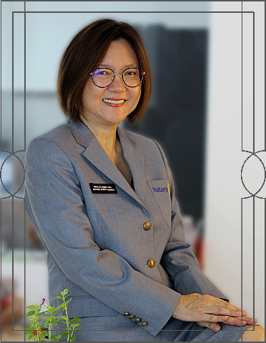
Message from
District Governor 2021-2022
Dear President (insert name) and Members of the Board of Directors,
Thank you for giving me the opportunity to pen my thoughts in your club's installation magazine which I am greatly honoured.
Let me congratulate you and your board members for taking up the leadership roles of your club especially during this COVID-19 pandemic when we are faced with so many challenges and uncertainties.
Rotary International President Shekhar Mehta addressed his District Governors as the MOVERS. And may I invite all of you too to be MOVERS and together we adopt his guiding mantra “Do more and grow more”. He said, friends, “Do more” as in bigger and impactful service projects, and “grow more” as increasing our membership and expanding our participation. As one of the active clubs in our District, I am confident that with this guiding mantra you will continue to excel in your community service projects, your generous contributions to The Rotary Foundation and will continue to provide that strong support to the District community services as well as in its many organised activities and functions.
I would like to congratulate Immediate Past President (insert name) and his/her (delete one) entire team for a great year of service despite having faced many obstacles in this difficult situation. The community that they have served are appreciative of them.
As I mentioned in my speech at the Governor’s Banquet, my dream has been shattered by this pandemic, but not my heart, because of the strong Rotary spirit in me. I am sure this goes the same with you too. We are in one big family of Rotary. The flame of our Rotary spirit keeps on burning, motivating us to reach out to our community in needs, despite the challenges facing us.
I look forward to the day when it is safe to travel again, when the borders are opened and when there is no fear to enable me to meet all of you and rekindle our Rotary fellowship and bonding.
Rotary is a beautiful organisation, and I am very proud to be a Rotarian. In this Rotary journey of mine, I find that ....
ROTARY is a place to be for it has changed my life.
ROTARY giving, we changed the lives of others.
ROTARY, I believe is good for the heart and soul.
I wish you all the best and, together as a team, we have the power and the magic to change lives. Let us be motivated, inspired and encouraged to grow more to do more.
Yours in Rotary

