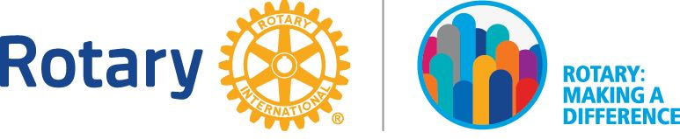
2015-2016 DISTRICT AWARDS AND RECOGNITION
District Most Outstanding Young Rotarian Award

Submission deadline 2 April 2018

This award is to be presented to the Most Outstanding Young Rotarian in District 3310.

Criteria:

- Must be 40 years old and below;
- Must be a member in good standing, i.e. good attendance, dues current, etc.;
- Must have demonstrated exemplary service through their involvement in each of the Five Avenues of Service (Club Service, Community Service, Vocational Service, International Service and Youth Service)
- Must be active in the community;
- Must have attended Membership/Rotary Foundation & Public Image seminar;
- Must have introduce at least 1 new member to Rotary;
- Meet professional standards and ethics (exemplify the Four Way Test).

I wish to nominate the following individual as the 2017/18 Most Outstanding Young Rotarian of the Year:

Name : _____________________________________________________
Age : _____________________________________________________
Joined Rotary : _____________________________________________________

I believe this individual is worthy of this special recognition because:
___________________________________________________________________________________________________________________________________________________________________________________________________________________________________________________________________________________________________________________________________________________________________________________________________________ (please use a attachment for more details)
Club President Name : _____________________________________________________
Club : _____________________________________________________
Date : _____________________________________________________

============================================================================
Submit completed form plus any appendices IN SOFT COPY by 2 April 2018 to
PP Li Guang Sheng at guangsheng.rotary@yahoo.com.sg with copy to:

Thank you for your participation!

