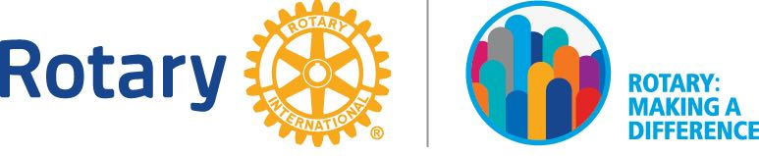
2015-2016 DISTRICT AWARDS AND RECOGNITION

BEST PROJECT WITH PUBLIC RELATIONS CONTENT

Submission Deadline: 2 April 2018

[Submissions can be made based on projects encapsulating the 4 Avenues of Service where important public relations activity/content is generated]

Rotary Club of _____________________________________________
Name of club president: _____________________________________
Signature of club president (required): __________________________ Date: ___________________

A project that demonstrates leadership of public relations strategies and tactics to enhance, promote or improve the reputation of Rotary, your club and the project with its key publics.

- Project name: _______________________________________________________________

- Briefly describe the project. Its goals and purpose. Where it was based. Who (if any local or foreign partners) were involved? How the project was executed.

___________________________________________________________________________
___________________________________________________________________________
___________________________________________________________________________
___________________________________________________________________________
___________________________________________________________________________
___________________________________________________________________________
___________________________________________________________________________

- What was the public relations message and who were your key public/s?

___________________________________________________________________________
___________________________________________________________________________
___________________________________________________________________________
___________________________________________________________________________
___________________________________________________________________________
- What was the public relations strategy?

___________________________________________________________________________
___________________________________________________________________________
___________________________________________________________________________
___________________________________________________________________________
___________________________________________________________________________

- What media, including new media, was targeted / used to support your project’s PR strategy?

- ____________________________________________________________________
- ____________________________________________________________________
- ____________________________________________________________________
- ____________________________________________________________________
- ____________________________________________________________________

- What tactics were used to engage the media?

Traditional Media

__________________________________________________________________________
__________________________________________________________________________
__________________________________________________________________________
__________________________________________________________________________

New Media

__________________________________________________________________________
__________________________________________________________________________
__________________________________________________________________________
__________________________________________________________________________
- How much coverage did the effort result in? Briefly describe:

___________________________________________________________________
___________________________________________________________________
___________________________________________________________________
___________________________________________________________________
___________________________________________________________________
- In the resulting media coverage, did it:
- Mention Rotary in a strong and positive light? Yes / No
- Mention your club and the project in a strong and positive light? Yes / No
- Mention Rotary volunteers’ efforts to address critical issues including Rotary’s End Polio campaign, peace and conflict resolution, disease prevention and treatment, water and sanitation, maternal and child health, basic education and literacy, economic and community development? Yes / No
- Endear Rotary International and the club to the hearts and minds of the community? Yes / No

- Did you attempt to measure the success of your PR campaign to better prepare for future efforts? What method did you use to do so? Briefly describe and attach any relevant findings/reports.

___________________________________________________________________________
___________________________________________________________________________
___________________________________________________________________________
___________________________________________________________________________
___________________________________________________________________________

- Please attach the following relevant material together with this form:-

Press release/press kit material
Newspaper/magazine clippings of coverage
Screen grabs of digital media coverage
Videos and/or photos that were circulated to the media
Presentations and speeches

=============================================================
Submit completed form plus any appendices IN SOFT COPY by 2 April 2018 to
PP Elsie Chua at chuakle@gmail.com +65-9782 3883

