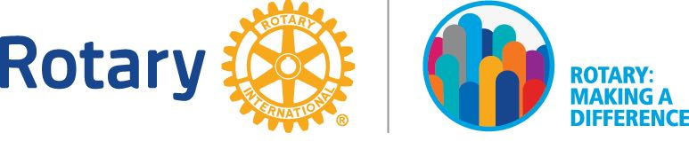
2017-2018 DISTRICT AWARDS AND RECOGNITION

Best iNTERACT CLUB PROJECT

Submission Deadline: 2 April 2018

Rotary Club of _____________________________________________
Name of club president: _____________________________________
Signature of club president (required): __________________ Date: ___________________
Sponsor Club:

Project Narrative
Briefly describe the project.

- Project name:

Start & Finish Dates:

2. Project Beneficiary: School Community (*Local / Foreign)
*Delete where applicable

Others (please describe): _______________________________________________________

Areas of focus. Select all that apply.
Peace and conflict prevention/resolution
Disease prevention and treatment
Water and sanitation
Maternal and child health
Basic education and literacy
Economic and community development etc

- Where is the project based? Select all that apply.
Singapore
Johor
Melaka
Sabah
Sarawak
Labuan FT
Brunei Darussalam
Others (specify): _________________________________ RI District: _________

- Why and how did your club initiate this project? What were your objectives?

- What was accomplished? (Photographs can help to tell your story. Submit photographs that show beneficiary participation and demonstrate Interact involvement in the project. Total maximum file size of photographs: 5 MB)

Interact involvement and oversight.

- How did Interactors manage and oversee the project?

- Names of partner organizations (if any):

- Interact / Rotaract Clubs:
- Private sector entities: -
- Government agencies: -
- NGOs: -
- Others (specify): -

- Describe the role played by partner organizations.

- Participants:
- Number of Interactors from your club:
- Number of Interactors from other club/s:
- Number of Rotarians from sponsor or other Rotary clubs:
- Number of participants from partner organizations:
- Number of other family members:
- Others (specify):

- In what ways did Interactors from your club/other clubs participate in/contribute to the project? List all non-financial involvement.

- In what way did your Rotarian advisor/Teacher Adviser contribute to this project?

- In what ways did the partner organizations participate in/contribute to the project? List all non-financial involvement.

Community Impact.

- How many people benefited from the project?

- What was the impact both short-term and long-term of the project on the beneficiaries?

- Any follow-up plans? If yes, briefly describe.

Resources.

- What resources were required for the successful execution and completion of the project?

- Cost of the project:
- How were funds raised?
- Materials/equipment/tools used:
- How were they acquired?

Additional feedback.

- Interact impact. Select all that apply.
Our club’s international Interact connections are stronger as a result of this project.
Club membership has increased as a result of this project.
Visibility of Interact in our school/community has increased.
Our club’s awareness of the needs in our community has increased.
Volunteer activity in our club has expanded.
Our club is more active in pursuing other service projects.
Participation in this project has not changed our club in any significant way.

=============================================================
Submit completed form plus any appendices IN SOFT COPY by 2 April 2018 to jameslee071@gmail.com + 65-9688 0862

