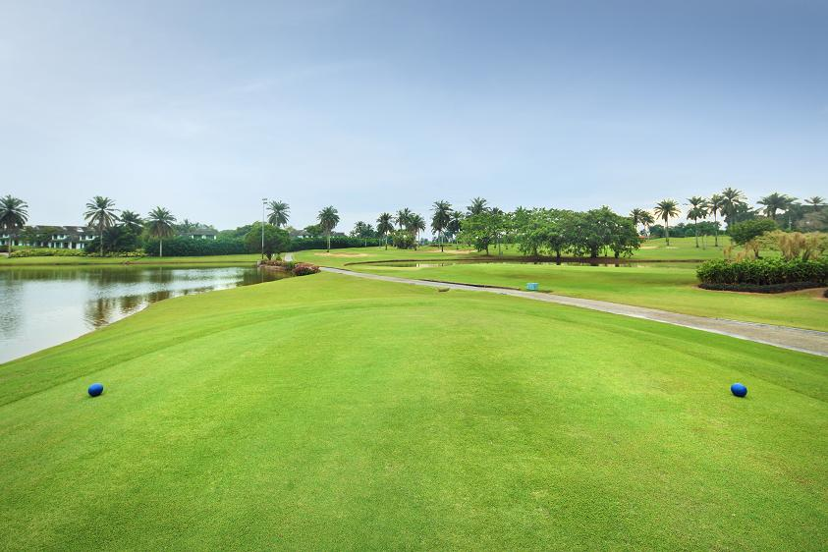
REGISTRATION FORM
RM 2000 per flight of four
RM 500 per individual entry
Breakfast served at 7.00am onwards
Lunch with Prize Giving
Attractive Prizes with lucky draw including novelty prizes
Top Prize for hole in one is a Honda City Car

Name H/cap Contact No Email
1
2
3
4

*Kindly include yr Membership No after your name if you are a member of Tg Puteri Golf resort
OR Cash Donation RM…………………
Completed Reg. Forms together with Cheques payable to :Rotary Club of Johor Bahru to be sent to
Freddie Lee at: Seri Alam Properties Sdn. Bhd.
8, Jalan Suria, Bandar Seri Alam. 81750, Johor Bahru.
HP: 012-7001862, Fax: 07-3865160,
Email: freddie@umland.com.my
Or pay to our Hong Leong Bank Bhd account: 00500047374 and fax details to Freddie Lee at 07-3865160

ROTARY CLUB OF JOHOR BAHRU
CHARITY GOLF 2014
23rd April 2014 at 8.00am
Tanjong Puteri Golf Resort

