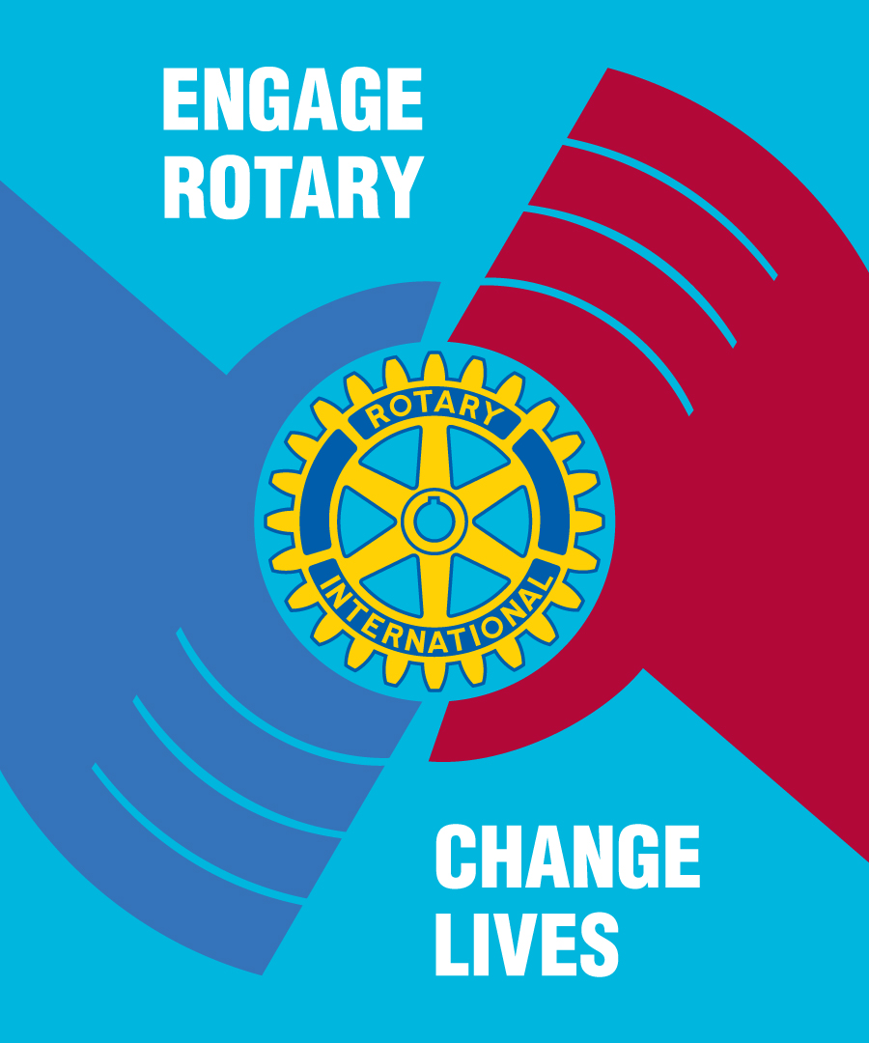

ROTARY INTERNATIONAL
District 3860
Philippines

July 28, 2026

Chew Ghim Bok
District Governor
RI District 3310, Malaysia/Singapore
Dear DG Bok,
Thank you very much for your very generous donation of P2, 155,113.50 Philippine Peso (net of bank charges) we received last November 26, 2013.
On November 8, 2013, the world saw how the Philippines was devastated by the strongest typhoon Haiyan (Local name: Yolanda) to date, killing more than 6,000 Filipinos and displacing millions of lives either without food, water, shelter and means of income, badly hitting the areas of Northern Cebu, Ormoc, Tacloban, Samar, and the rest of Central Visayas.
The kindness you have shown will help the victims of the tragedy restore much of what have been lost and bring back hope to their lives and family.
We have already used the funds you donated with the purchase, and delivery of roofing materials (G.I. sheets), roofing nails and carpentry tools to two elementary schools in Ormoc and two elementary schools in Tacloban that were damaged during the typhoon. Total expenditures spent during this portion of our relief, rebuilding and recovery mission was P 2, 754,341.52
In behalf of Rotary District 3860, we extend our deepest gratitude to your being part of our continuing effort in assisting our countrymen withstand the sufferings and challenges they are facing.
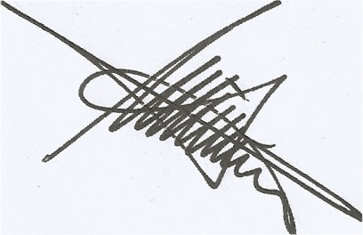
Yours in Rotary,
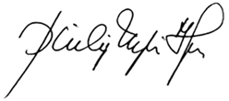
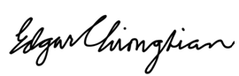
Edgar R. Chiongbian Philip N. Tan Wilton Uykingtian
District Governor District Secretary Chair, D.R.R.R.C.

Donation ACKNOWLEDGEMENT Receipt
Organization : Rotary International District 3310
Date Received : November 26, 2013
Cash Contribution : P2, 155, 113.50 Philippine Peso
Deposited to : Rotary District 3860 Disaster Fund
Bank of the Philippine Island – MEZ 2 Branch

