ROTARY CLUB BALI KUTA
DISTRICT 3420 INDONESIA

Charter Date : June 30, 1989
No of members : 48 active members & 2 Honorary members

Contact Us:
Rotary Club Bali Kuta
ID # 26697, Secretariat:
Jl. Raya Kuta 127, Cempaka Lane, Kuta 80361
Bali – Indonesia
Weekly Meeting place:
Pelangi Restaurant
Jl. Dewi Sri, Kuta
Day: Wednesday, Hour: 12.30
Excecutive Secretary:
Lita, tel: +62.361. 753174, Fax: +62.361. 754934, 081236280384
email: rotary@balikuta.org
President:

Marina Purwa , Tel.: +62.81.1392267
ID# 6988950
marinapurwa@kcbtours.com
Club Secretary:

Barbara Purwa, Tel.: +62.81.23972840
barbarapurwa@kcbtours.com
President Elect:

Handoko Omar: 08123844548, handoko_cor@yahoo.co.id
President Nominee:
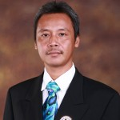
Slamet Widodo : 08123931135
Club Advisor & TRF Comm Chair:
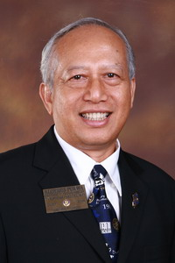
PDG Al Purwa, Tel.: +62.81.5570.4444
ID# 1598770
purwa@rotary-d3400.org

Club Location : Kuta, Bali, Indonesia

Secretariat : Jl.Raya Kuta Gg.Cempaka
Phone : +62.361.753174 / Fax : +62.361.754934

Contact Person : PDG Al Purwa, Email : al@purwa.me
cc to club executive secretary : rotary@balikuta.org

Signature Projects : 1. Clean water and sanitation in Tabanan - Bali and Sumba island
2. Bali blood bank
3. Literacy project in Bali and Sumba island
4. Health check and medicine project in Bali
5. Culture preservation in Bali

More information about our projects go to: www.rotary.balikuta.org

About Us:
Rotary Club Bali Kuta was chartered on 30 June 1989 with the sponsor club RC Bali Sanur, and the charter members were 25 Rotarians. Aloysius Purwa was the charter President of this club, the first meetings were done at the older Kartika Plaza hotel, then moved to Pertamina Cottages (now known as The Patra) for some years, after that meeting place was moved to the Santika Beach Hotel, and now for the last 4 years Rotary Club Bali Kuta is meeting every Wednesday, 12.00 noon at the Pelangi Restaurant, Jalan Dewi Sri, Kuta – Bali
We have many Past Presidents now, but only 4 of the Charter members are still remaining with the club and the current President for 2009-2010 is Ratnawati Hartoyo. For many years Rotary Club Bali Kuta only had male members, but now we have 5 female members and soon we expect we will be about fifty-fifty.
Our members today are 32 Active and two honorary members and he is H.E. the Governor of Bali Mr. Made Mangku Pastika. President Winaya’s goal is 37 members on his ending term.
Kuta is a world famous place for tourism, especially for Australians who consider this town their second home. People are coming and going very fast from about 175 countries as visitors as well as long stay guests. And therefore our members are also changing quite fast based on their job conditions and traveling needs.
The 4 charter members who are still active at Rotary Club Bali Kuta are: PDG Al Purwa, DG Panudiana Kuhn, PP Gunawan Kantawibawa and PP Arya Budi Giri, all of them are Paul Harris Fellow and a Major Donor.
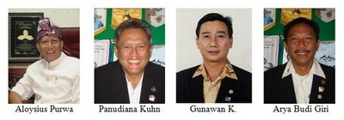
For the year 2010-2011 this club will host or produce a District Governor for D3400, namely the Charter President of this Club Al Purwa, and of course every member will be given one or more task to be active on the District level.
And for the year 2013-2014 one of the charter member Panudiana Kuhn will become a governor as well, and if the District is divided into two, his term will become sooner and that is 2012-2113. RC Bali Kuta is becoming more vibrant and alive when many members enggage themself better.
And for the year 2014-2015 PP Hanny Arianto from this Club will be the 3rd District Governor for D3420 in Indonesia, and he is also a Major Donor Level 2.
In 2012 DG Ridlo named RC bali Kuta as the Best Rotary Club in Indonesia based on its High support to TRF, Everyone donated and high donation per Capita, the greatest growth from 27 members to 47 members, and many of its sustainable projects.
CLUB BANNER:
Rotary Club Bali Kuta’s banner consists of 3 important element that shows the life and surrounding of our club in Kuta – Bali Indonesia, they are :
Balinese split gate that is called “Candi Bentar” symbolizing the warm welcome to Bali, we welcome tourists from more than 175 countries of the world.
Beach, that is the description of the famous Kuta Beach, where people come from all over the world to swimm, run, surf, massage,walk or just sit down to see others passing by.
Sun-set, is hapening every afternoon where thousands of tourists waiting to watch it at the Kuta Beach while holding a glass of margarita, pina-collada, whisky cola, red wine or rum jungle creations. And it looks like below:
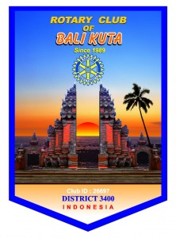
If your club like to have an exchange banner with Rotary Club Bali Kuta, please send us one of yours and give us your address, we will send you one with a greeting note from our club President.

