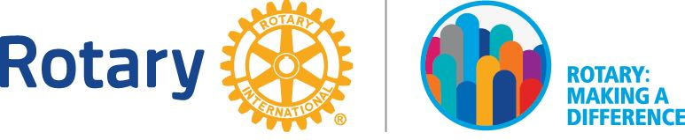
2017-2018 DISTRICT AWARDS AND RECOGNITION

Best Community Service PROJECT

Submission Deadline: 2 April 2018

Rotary Club of _____________________________________________
Name of club president: _____________________________________
Signature of club president (required): __________________ Date: ___________________
Project Narrative
Briefly describe the project.

- Project name:
- Project Start and Completion Date:

3. Areas of focus. Select all that apply.
Peace and conflict prevention/resolution
Disease prevention and treatment
Water and sanitation
Maternal and child health
Basic education and literacy
Economic and community development

- Where is/was the project based? Select all that apply.
Singapore
Johor
Melaka
Sabah
Sarawak
Labuan FT
Brunei Darussalam
Others (specify): ______________________________________RI District: _________

What were your objectives?

- What was actually accomplished? (Submit photographs and other materials that show beneficiary participation and demonstrate Rotarian involvement in the project. Total maximum file size of photographs: 5 MB)

- How did Rotarians manage and oversee the project?

- Names of partner organizations (if any):
- Rotary clubs:
- Private sector entities:
- Government agencies:
- NGOs:
- Others (specify):

- Describe the role played by partner organizations.

- Participants:
- Number of Rotarians from your club:
- Number of spouses from your club:
- Number of Rotarians from other Rotary clubs:
- Number of participants from partner organizations:
- Number of other family members:
- Others (specify): Friends:

- In what ways did Rotarians from your club participate in/contribute to the project? List all non-financial involvement.

- In what ways did Rotarians from the international partner clubs participate in/contribute to the project? List all non-financial involvement.

- In what ways did the partner organizations participate in/contribute to the project? List all non-financial involvement.

Community Impact.

- How many people benefited from the project?

- Who are the beneficiaries of the project?

- What was the impact of the project on the beneficiaries?

- What are the expected long-term community impacts of the project?

- Any follow-up plans? If yes, briefly describe.

Resources.

- What resources were required for the successful execution and completion of the project?

- Cost of the project:
How were funds raised?
- Materials/equipment/tools used:
How were they acquired?

Additional feedback.

- Rotary impact. Select all that apply.
Our club’s international Rotary connections are stronger as a result of this project.
Club membership has increased as a result of this projectVisibility of Rotary in our community has increased.
Our club’s awareness of the needs in our community has increased.
Volunteer activity in our club has expanded.
Our club is more active in pursuing other service projects.
Participation in this project has not changed our club in any significant way.

- Project sustainability. Select all that apply.
The project will continue to function without further input from our club.
Equipment purchased is being maintained with local materials and expertise.
This project has provided the recipients with the skills, knowledge, or institutions that will allow them to help themselves.
The project has not been sustainable.

=============================================================
Submit completed form plus any appendices IN SOFT COPY by 2 April 2018 to:
PP Chew Kian Wee : kwchew@zoncengineering.com +60-16-773 2736

